Jumat, 30 November 2018

CI/CD
By Mas Amir

- Open heroku (heroku.com).
- Create new app, in this case i’ll use domain belajar-cicd.herokuapp.com, see picture below:
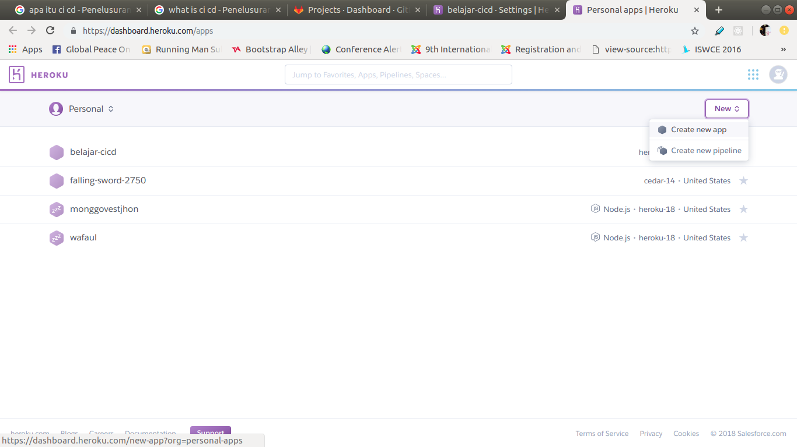
- Go to section settings:
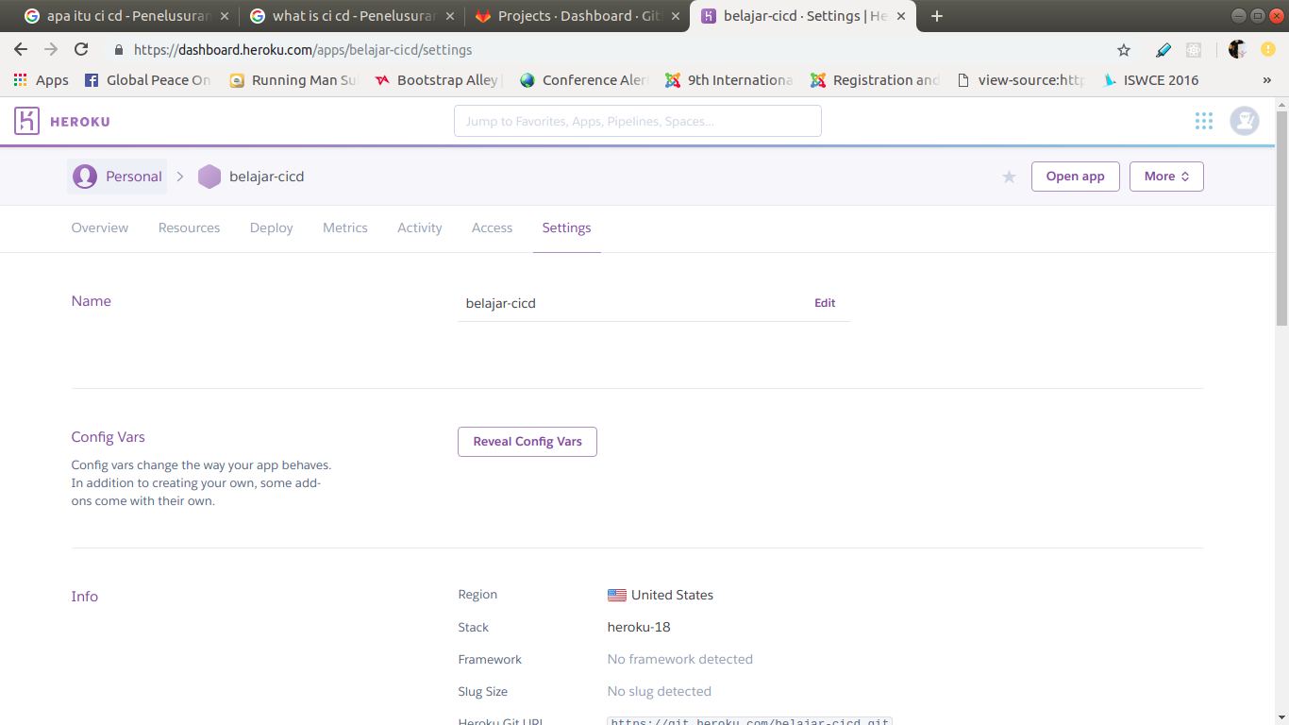
- Choose Add buildpack:
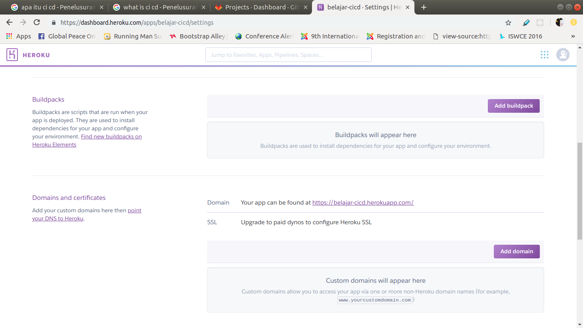

- Type mars/create-react-app and then click Save Changes:
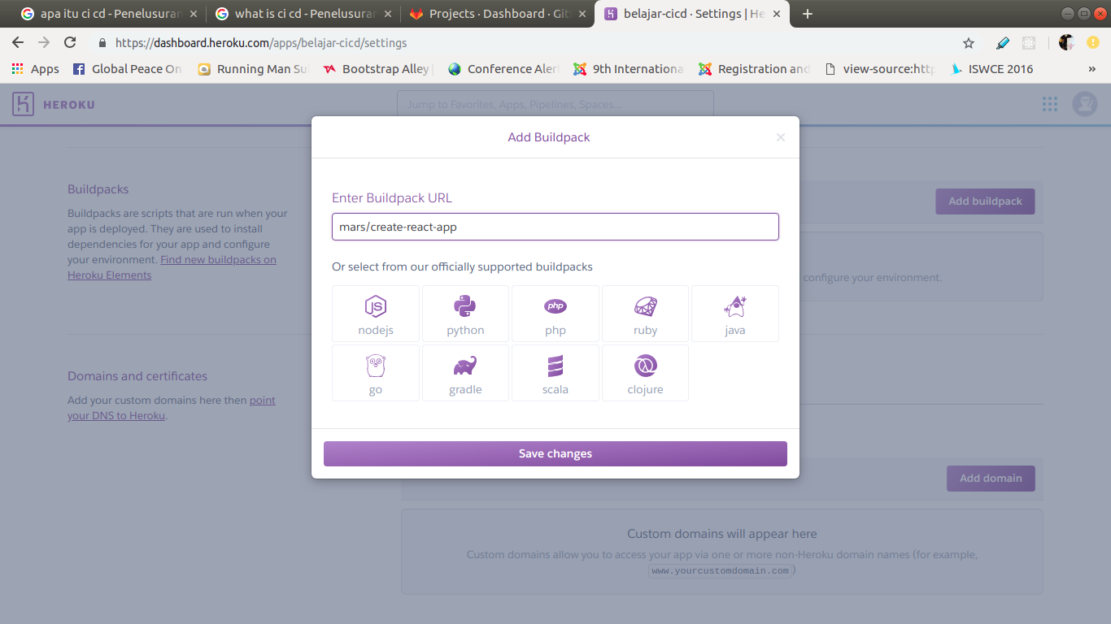

- This is the new domain deploy in heroku:
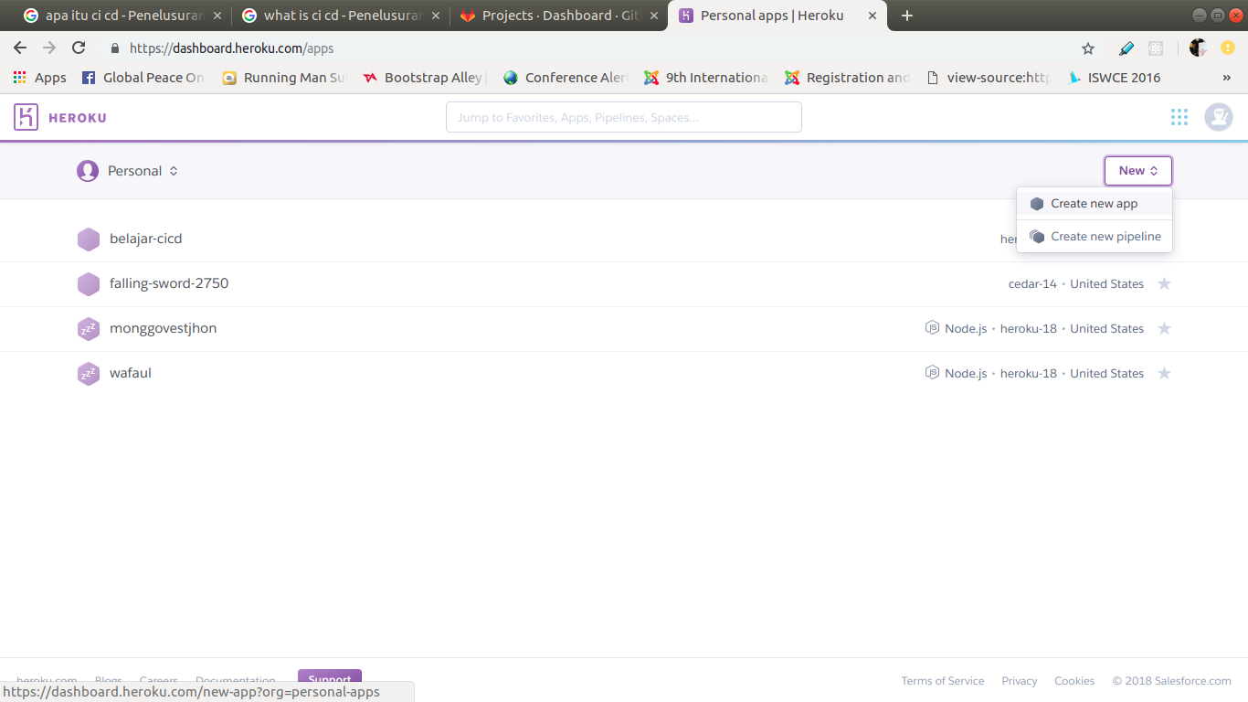
- ASAS

